ANNUAL EXAM [2022-23]
Class: IX [Science] Date: 10/03/2023 Time: 3 hrs. MM: 80

General Instructions:
- This question paper consists of 39 questions in 5 sections.
- All questions are compulsory. However, an internal choice is provided in some questions. A student is expected to attempt only one of these questions.
- Section A consists of 20 objective type questions carrying 1 mark each.
- Section B consists of 6 Very Short questions carrying 02 marks each. Answers to these questions should be in the range of 30 to 50 words.
- Section C consists of 7 Short Answer type questions carrying 03 marks each. Answers to these questions should in the range of 50 to 80 words
- Section D consists of 3 Long Answer type questions carrying 05 marks each. Answers to these questions should be in the range of 80 to 120 words.
- Section E consists of 3 source-based/case-based units of assessment of 04 marks each with sub-parts.
SECTION - A
Select and write one most appropriate option out of the four options given for each of the questions 1 – 20
- Which of the following is not a matter?
a)Stars b) plants c) Animals d)Magnetism
- A mixture of Sulphur and carbon disulphide is
  - heterogeneous and shows Tyndall effect c) homogeneous and shows Tyndall effect
  - heterogeneous and does not show Tyndall effect d) homogeneous and does not shows Tyndall effect
- The symbol of Ag represents
a)Argon b)Arsenic c)Silver d) gold
- Atoms of the same element having different masses are called
a)isobars b)isotones c) isotopes d)none
- The pair of solutions which show tyndall effect is
a)starch,milk b) starch and sodium chloride solutions
c) sodium chloride and copper sulphate solutions d)milk and sugar solution
- Which of the following is not correct?
  - All orbits around the nucleus are equally spaced
  - The energies of the shells decrease as we move outwards
  - The shells are called stationary states because they have fixed energies
  - The energy is emitted when the electrons jump from outer to inner shells
- Molecules of which of the following elements are polyatomic?
  - oxygen and sulphur b) Sulphur and phosphorus
c)Phosphorus and oxygen d) d) ozone and nitrogen
- Identify the type of cell shown in the figure below.
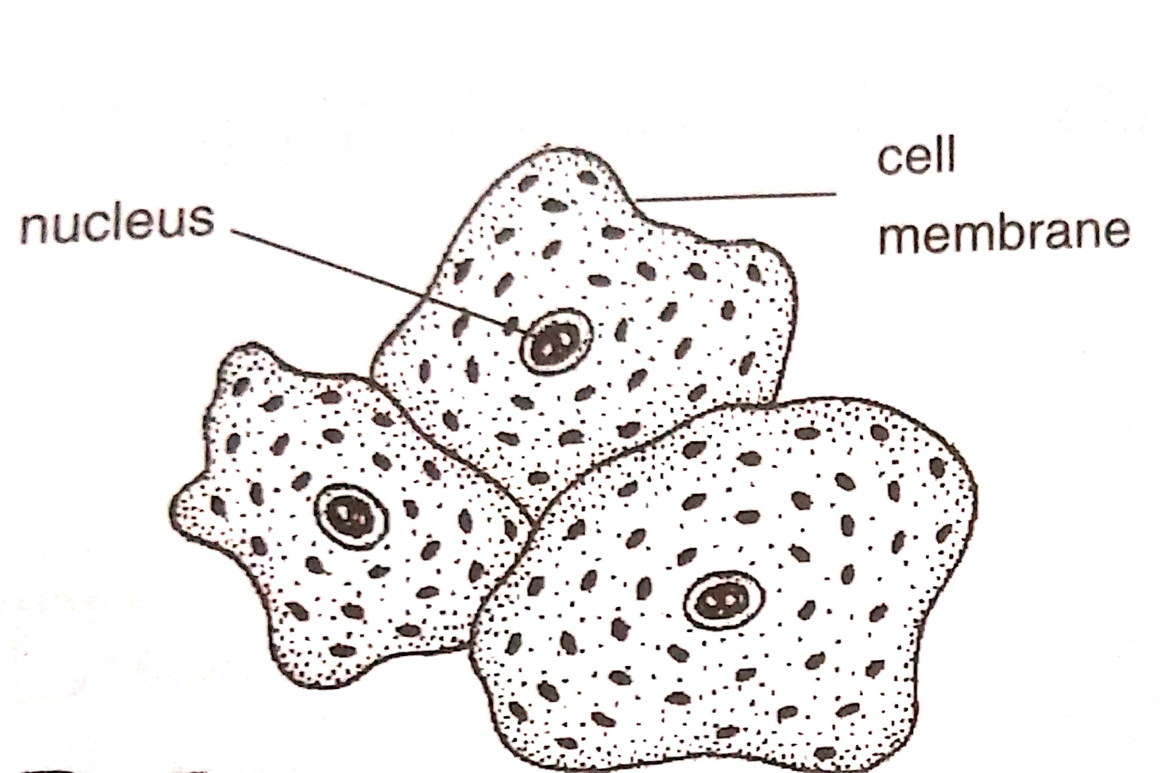
a) Onion cell b) Cheek cell c) Prokaryotic cell d) none of these
- Aerenchyma is mainly found in
a) Xerophyte b) Hydrophyte c) Mesophyte d) Halophyte
- A toxic substance effective against insect is
  - Weedicides b) Insecticide c) Fungicide d) All of these
- Which of the following species of honey bee is an Italian species.
  - Apis dorsata b) Apis florae c) Apis indica d) Apis mellifera
- Rapid increase in oil production is called
  - Green revolution b) Blue revolution c) White revolution d) Yellow revolution

Q13. When the Distance travelled by a body is directly proportional to time, it is travelling with
a) uniform acceleration b) non uniform acceleration
c) constant speed d) variable speed.
Q14. Newton's first law of motion is also known as
(a) law of momentum (b) law of force (c ) law of energy (d) law of inertia.
Q15. Gravity is the force of attraction between
(a) the sun and the moon (b) the moon and the satellite
(c ) the earth and object (d) the Sun and Jupiter.
Q16. In case of negative work the angle between the force and displacement is
- 0° (b) 45° (c ) 90° (d) 180°
Q. no 17 to 20 are Assertion - Reasoning based questions.
These consist of two statements – Assertion (A) and Reason (R). Answer these questions selecting the appropriate option given below:
(a) Both A and R are true and R is the correct explanation of A
(b) Both A and R are true and R is not the correct explanation of A
(c) A is true but R is false
(d) A is False but R is true
- Assertion (A): number of protons present in the atom of an element is a fixed number but number of neutrons is not fixed.
Reason(R): Neutron is a neutral particle.
- A: A fully turgid cell is called deplasmolysed.
R: Deplasmolysis involves endosmosis of water.
- A: Phloem is a compound tissue of vascular plants.
R: Phloem helps in unidirectional conduction of food.
- Assertion: Stethoscope works on the principle of reflection of waves
Reason :Bats produce infrasonic waves.
SECTION – B
Q. no. 21 to 26 are very short answer questions.
- What are the postulates of Dalton's atomic theory.?
OR
How do you define the valency of an element in a molecular compound?
- State the functions of various corpuscules of human blood.
- List the characteristics of parenchyma.
- An object has moved through a distance. Can it have zero displacement? If yes, support your answer with an example.
- State Newton second law of motion.
OR
Why do you fall in the forward direction when a moving bus brakes to a stop and falls backward when it accelerate from rest.
- Define organic farming. Why is it important to us.
OR
What is a Hybridization? Discuss the role of hybridization in crop improvement.
SECTION - C
Q. no. 27 to 33 are short answer questions.
- a) Give the schematic atomic structures of chlorine atom and chloride ion.
  - Name the elements which have the following electronic configuration:
1)2,6 2)2,8,1
- a) Write two differences between boiling and evaporation.
- Convert the following temperatures into the Kelvin scale:
a)27 °C b)373°C
- a) Which cell organelle is the powerhouse of the cell.
- What is the fundamental unit of life who discovered it how they can be observed.
OR
      - Which cell organelle would you associate with elimination of old and worn out cells. Why?
      - Name two cell organelles which are bounded by a double layered membrane. Give one function of each.
- What is the work to be done to increase the velocity of a car from 30 km /h to 60 km/ h, if the mass of the car is 1500 kg?
- A stone of 1 kg is thrown with a velocity of 20 m/s across the frozen surface of a lake and come to rest after travelling a distance of 50 m. What is the force of friction between the stone and the ice?
- Distinguish between speed and velocity
OR
What can you say about the motion of an object if its speed -time graph is straight line parallel to the time-axis?
What is the nature of distance time graph for uniform and non uniform motion of an object?
- Draw a well labelled diagram of a nerve cell.
OR
Differentiate sclerenchyma and collenchyma.
SECTION D
Question number 34 to 36 or short answer question
- a) Calculate the molecular masses of
i)NH3 ii) 2)Na2O
(Given atomic masses of N=14,H=1,Na=23,O=16)
b) Give the chemical formulae for the following compounds and compute the ratio by mass of the combining elements in each one of them.
i) Hydrogen chloride ii) Carbon monoxide
c) What is the difference between mass number and atomic number.
OR
a) State law of conservation of mass and explain it giving suitable example.
b)A 0. 24g sample of a compound of oxygen and boron was found by analysis to contains 0.096 gram of boron and 0.144 gram of oxygen . Calculate the percentage composition of the compound by weight.
c) Which atom does not have any neutron in the nucleus and why?
- Discuss structure and function of nucleus using a well labelled diagram.
OR
Draw a well labelled diagram of plant cell and comment on it.
- (a) Give two practical applications of multiple reflection of sound wave.
(b)What is reverberation? How can it be reduced.
(c )What are wavelength and frequency of a sound wave.
SECTION E
Question number 37 to 39 are case base / Data-based questions with two or three short sub parts. Internal choice is provided in one of these sub- parts.c
- Depending upon the particle size, solution are divided into three categories :(1) true solutions,(2) colloidal solutions and 3)suspensions. Due to particle size, colloidal solutions lying in between those of true solution and suspensions.colloidal solutions have a special properties such as colloidal particles carry charge,show Brownian movement and Tyndall effect due to scattering of light.
Answer the following question on the basis of above paragraph
      - What is the reason for the difference in the properties of solutions, colloids and suspension?
      - What is the particle size of a colloidal solution?
      - What is observed when a beam of light is passed through a colloidal solution ?what is this effect called?
- Case study: Read the passage and answer the questions.
The livestock refers to domestic animal which provide us milk,hide or flesh and includes cattles, buffaloes, sheep,goat,pigs,yak etc. Livestock production needs to be improved to meet them to growing needs of milk, eggs, meat etc. Out of these, cattle raising is most important and is done for two purposes : milk production and Bullock labour.
- What is animal husbandry?
- Suggested the ways by which we can enhance the food production.
- How animal husbandry is one of the main source of income for farmers.
OR
Name one of the Indian breed of cow and buffalo.
- We know that the earth attracts every object with a certain force and this force depends on the mass (m) of the object and the acceleration due to the gravity (g). The weight of an object is the force with which it is attracted towards the earth. Mathematically
W = m x g
Where, W= weight of object
m= mass of object
g= acceleration due to the gravitational force
As the weight of an object is the force with which it is attracted towards the earth, the SI unit of weight is the same as that of force, that is, Newton (N). The weight is a force acting vertically downwards; it has both magnitude and direction. We have learnt that the value of g is constant at a given place. Therefore at a given place, the weight of an object is directly proportional to the mass, say m, of the object, that is, W α m. It is due to this reason that at a given place, we can use the weight of an object as a measure of its mass. Answer the following questions.
(i) Unit of acceleration due to the gravity (g) is
(a) m/s (b) m/s² (c) Newton(N) (d) None of these
(ii) Which of the following has same unit
(a) Mass and weight (b) Weight and force
(c) Velocity and acceleration (d) None of these
(iii) Whether weight is scalar quantity or vector quantity? Justify your answer.
OR
Differentiate between mass and weight.

